HELP for FIFO/BIBO/DIDO workers and families:

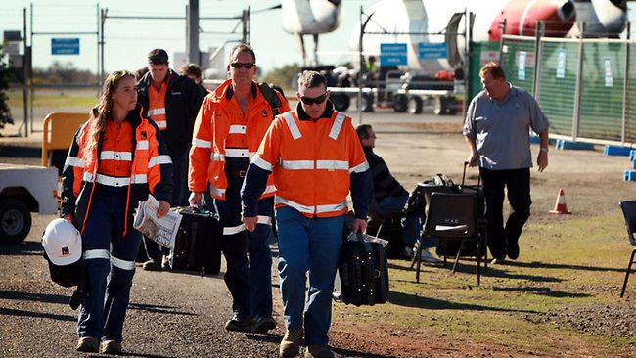
FIFO work comes with so many great benefits. Whilst the gains from this type of work are substantial, the undesirable impact this type of work is having on individuals, couples, and family units is becoming hard to ignore.
One great obstacle to fully enjoying FIFO work is a behavioural attitude of seeking HELP when you need it.
Joanne Wilson is a caring, compassionate and professional Counsellor with first-hand experience on the challenges of working and living away from home.
Some ways that FIFO work can impact workers:
- A sense of isolation and loneliness that can lead to depression.
- Time away from a partner can lead to fantasies about partner being unfaithful or not interested leading to insecurities.
- Difficulties forming new relationships if single.
- Changes in mood are often experienced by FIFO workers.
- Fatigue due to very long shifts
- Missing significant events such as birthdays and weddings
- Often high levels of stress
- Struggling to feel part of the community due to long stretches away.
- A sense of not 'belonging' anymore.
Ways it can affect families:
- Relationships become strained
- One parent often takes on the role of single parent
- Children are impacted emotionally spending time looking forward to Mum or Dad's return and then having to say good bye again.
- FIFO workers find it difficult to adjust from single life to family life
- Both partners need down time, time with each other, and time with their children. (Very difficult to juggle as the parent who stays at home with the children needs some time out from being a single parent and the FIFO worker needs time to wind down after working such long hours.)
- Greater use of pornography
If you are experiencing coping difficulties, or your relationships are starting to suffer as a result of fly in fly out or similar work, please contact Jo Wilson, TheConfidante on 0499991884 or jo@theconfidantecounselling.com to further discuss your concerns. Personal sessions at our ocean side practise based on the Sunshine Coast are welcome, however Skype, Iphone Facetime or telephone appointments can be just as beneficial.
Using the internet or smart phones for counselling and psychotherapy is actually a great use of our modern technology and the internet. It makes it easy for you to work with a counsellor no matter where you work or live.
Skype is a free, high quality video conferencing program that allows us to talk together (and see each other) using your computer with speakers (or a headset) and a webcam usually a component if most Computers, Ipads tec. Skype is free to download and easy to install.
Skype communication is completely confidential. All Skype communications are fully encrypted, even more so than your telephone probably is, so rest assured that Skype is fully confidential.
Benefits of Telephone, Iphone "Facetime" and Skype Counselling can be very convenient:
- Address issues in a timely manner wherever you are
- No commute or travelling required
- You stay in your private comfort zone
- No parking issues
- No childcare issues
- Easily accessible
- Can be done from the comfort of your own home
- You don't have to wear shoes or dress up
In the meantime, enjoy our FIFO/DIDO/BIBO Support Series on Facebook commencing this month!
Have you LIKED? https://www.facebook.com/TheConfidanteCounselling

